Design and Simulation of Sb₂Se₃-Based Resonant Optical Limiters Using Transfer Matrix Method
Undecided/under review
Check with reference again
Check logic

Prathan Buranasiri ¹, Cheat Padungatthakij ¹, Suebtarkul Suchat ², Surawut Wicharn ^{3*}
1 Department of Physics, School of Science, King Mongkut’s Institute of Technology Ladkrabang, 1 Chalongkrung Rd. Ladkrabang, Bangkok, Thailand 10520.
2 Department of Physics, Faculty of Science and Technology, Phranakhon Rajabhat University, 9 Chaengwattana Rd., Bang Khen, Bangkok, Thailand 10220.
3 Department of Physics, Faculty of Science, Srinakharinwirot University, 114 Sukhumvit 23 Watthana, Bangkok, Thailand 10110.
* Corresponding author; Email: surawutw@g.swu.ac.th

Journal & publication

Abstract
We proposed a novel optical limiter design utilizing asymmetric resonant cavities comprised of Sb₂Se₃ phase change material (PCM) layer. This design addresses the limitations of conventional optical limiting devices by exploiting the properties of Sb2Se3 , such as ultra-low loss in the infrared spectrum, relatively high and stable refractive index contrast in the visible and infrared spectrum, and very high phase switching endurance, in the order 106 cycles. The asymmetrical Fabry-Perot cavity designs were optimized for three distinct operating wavelengths. The design utilises Sb2Se3 layer(s) with appropriate thickness, ranging from 5 to 200 nm, sandwiched between two distributed Bragg reflectors for a complete anti-reflection design. We also investigated the non-linear effects due to Kerr’s effect, and the impact on the device operating intensity threshold. This design approach represents an advancement in nonlinear photonic devices, with superior performance metrics compared to traditional single or multi-layer designs.

Keywords: optical limiter, resonant cavity, phase change material, Sb₂Se₃

1. Introduction

Phase change materials (PCMs) have a different meaning depending on the topics [1]. When discussing about energy storage, the term would refer to materials that store and release thermal energy by changing their state of matter, (i.e. latent heat). The transition between phase is between solid and liquid [2]. However, in photonics and electronics, PCMs refer to solid-state material that change its crystalline structure when sufficient energy is applied, and the temperature rise above transition temperature (T_{trans}). The transformation of crystalline structure leads to a change in optical properties, such as the refractive index (n) [3]. The change in refractive index associated with nonlinear behavior due to phase transition is orders of magnitude larger than changes induced by an applied electric field or light intensity (Kerr effect) [4]. The large contrast makes PCMs ideal for photonic applications that behave similarly to a switch or a filter. Such as a tunable optical filter [5, 6], broadband absorber [7, 8], gas sensor [9], optical limiter [4, 10-12], optical switch [13, 14], or an optical diode [15].
Phase change material can be classified by their post phase-transition behavior. A volatile PCM reverts to their original phase if the temperature drops below T_{trans} but non-volatile PCM will remains in the transitioned phase. To return a non-volatile PCM to its pre-transitioned phase, a higher melting temperature needs to be reached and then rapidly quenched. A commonly studied PCMs in photonics thin film are Ge₂Sb₂Te₅ (GST), Ge-Sb-Se-Te (GSST), and Vanadium dioxide (VO₂).
A commonly studied non-volatile PCM is Ge₂Sb₂Te₅ (GST). It exhibits large refractive index contrast between the amorphous and crystalline phase [16]. It has a relatively low crystallization temperatures at ~180°C. Thin film devices made from GST can be thin due to a high refractive index contrast. A thin device with low transition temperature allows for an easy phase switching. But GST devices suffer from inefficiency due to a large extinction coefficient (k), which results in high optical loss. Ge-Sb-Se-Te (GSST) is a derivative of GST that substitutes some of the antimony to selenium. GSST has a lower optical absorption than GST but has a lower refractive index contrast. It also has a higher crystallization temperature, at around 265 °C, than GST [17].
In the past 10 years, Vanadium dioxide (VO₂) has gathered attention as a volatile phase change material with the closest metal-to-insulation transition (MIT) temperature to room temperature among other common PCMs, at 68 °C [6, 8, 18, 19]. It also has a relatively high refractive index contrast between the two phases in the infrared spectrum. Its drawback are a high extinction coefficient, and thermal hysteresis [20]. Even so, its low transition temperature and high refractive index contrast make it an attractive real-world designs such as energy-saving thermochromic window coatings that helps with room cooling by automatically blocking transmission when heated by strong sunlight during the summer, but allows high transmittance in the winter to help with indoor heating [19, 21, 22].
Antimony triselenide (Sb₂Se₃) was initially used in solar energy applications [23], but is an emerging non-volatile material in the field of photonic [24]. Unlike GST or GSST, it has low extinction coefficients in the infrared spectrum for both its amorphous and crystalline phases [14, 25], has a relatively stable refractive index contrast from the visible through infrared spectrum [16]. Its crystallization temperature is around 186 °C, comparable to GST [14], and is lower than other non-volatile PCMs. It also has been experimentally demonstrated to have high phase switching endurance of 4,000 cycles [16], or with an optimized laser-induced crystallization and re-amorphization process, can be on the order of 10⁶ cycles [14]. These properties make Sb₂Se₃ popular as a low-loss, reconfigurable photonic devices to be used in an optical waveguide [16, 17, 26-28]. But Sb₂Se₃ usage as an optical limiter has been mostly unexplored.
An optical limiter is a photonic device that allows light transmission in the normal ‘on’ mode. But will block transmission by absorption and/or reflection, when switched to ‘off mode. The devices can be designed to operate in a single [15, 29, 30] or broad wavelengths [4, 6, 11, 12, 15]. Optical limiter can be switched by self-heating from the high-intensity light of designed operating wavelength [11, 15, 30, 31] or it can also be manually switched by high-intensity light outside the operating wavelength [14]. Applications include a filter for sensor/eyes protector [11, 31], or integrated photonic circuits. Ideally, an optical limiter needs to have high transmission contrast between the on and off mode with low absorption in the on mode for high efficiency. A resonant cavity distributed Bragg reflector structure with antireflection design provides a solutions to both requirements [32]. At resonance wavelength, a constructive interference will maximize the transmission of the device. The device will change its operating mode by phase transition of PCM, the result refractive index contrast of the two phase will also be enhanced due to the cavity design. The resonant enhancement also means that the central PCM layer can be thinner than PCM in a standalone antireflection design. This benefit is more significant to a non-volatile PCM which has higher transition temperature. And since the use of thinner PCM layer results in a lower energy requirement for the crystallization or re-amorphization process, this is particular useful for non-volatile PCM which has high re-amorphization temperature. Another benefit of thinner PCM is the dampening of the stress due to the contraction and expansion of the crystallization and re-amorphization process [33], enhance the endurance, and help with the thickness limit of thin film design [14].
Since the photonic applications of Sb₂Se₃ are largely unexplored [24], we decided to investigated of Sb₂Se₃-based thin-film optical limiters. We chose to simulate multilayer approach (thin-film stacks) rather than a metasurfaces design since it’s more feasible to fabricates [31] while still provide the necessary resonance for a cavity design. To demonstrate the benefits and limitations of this design approach, we design the limiters for two distinct wavelengths: 532 and 1064 nm, which has high and low extinction coefficient, respectively [16].

2. Theory

2.1 Transfer matrix method
XXX

2.2 Multilayer antireflection thin film design
The simplest thin film device consists of a single subwavelength-thick film deposited on a substrate. By selecting film with an appropriate refractive index (n) and physical thickness (t) one can design a device that either highly reflective or have antireflective. Since all of the devices discussed in the introduction prioritize transmission or absorption and does not employ reflection for any operation, minimizing their reflectivity is beneficial. In this work, we will make our devices a perfect antireflection (AR) design. A single-layer AR design has 2 interfaces for reflection: the first interface is at the top of the thin film before light enter the film layer (air-film), the second interface is when light reflect at the substrate (film-substrate). Antireflection is archived when light from the second interface travelled π radian out of phase.
Since light travelled through the film layer twice, before and after reflected at the second interface, the film needs to be π/2 phases thick. This can also be described as an optical thickness of λ/4 or quarter-wave optical thick (QWOT). Optical thickness OT is defined as:
$OT=nt$, (1.1)
$\frac{λ}{4}=nt$, (1.2)
where n is the refractive index, and t is the physical thickness. For example, an AR design for 1,000-nm light needs to have thin film with physical thickness $t=\frac{1000}{4n}$ nm.

Another way to find film thickness for a multilayer AR design is to consider the reflectivity (r). First, we consider only the first reflection interface,
$r=\frac{n_{a}-n_{f}}{n_{a}+n_{f}}$, (2)
where n_{a} is the refractive index of air, and n_{f} is the refractive index of the film.

Next, if we considered reflectivity of both interfaces, n_{f} can be substituted by effective reflectance index (n_{r}), which can be thought of as the combined index of the all the film layers and substrate. A more detailed explanation can be found in Chapter 3 of [34].
$n_{r}=n_{f}\frac{\left(n_{s}+n_{f}\right)+\left(n_{s}-n_{f}\right)e^{-j2θ}}{\left(n_{s}+n_{f}\right)-\left(n_{s}-n_{f}\right)e^{-j2θ}}$, (3.1)
$r=\frac{n_{a}-n_{r}}{n_{a}+n_{r}}$, (3.2)
where θ is phase thickness and is related to the angular wave number (k₀) by
$θ=k_{0}n_{f}t$, (3.3)
$k_{0}=\frac{2π}{λ}$ . (3.4)

For perfect antireflection, n_{r} from equation 3.2 must be equal to n_{a} so that r will be zero. When the phase thickness is in a multiple of π/2, the exponent terms in equation 3.2 can be simplified to an integer of N:
$e^{-j2θ}=±1$, (4.1)
$θ=N\frac{π}{2}$ . (4.2)
Using Euler’s identity, and if N is odd number, θ will be equal to π. Equation 4.1 then become
$e^{-jπ}=-1$. (4.3)
By substituting in equation 4.3 to equation 3.2, n_{r} will be simplified to
$n_{r}=n_{f}\frac{\left(n_{s}+n_{f}\right)-\left(n_{s}-n_{f}\right)}{\left(n_{s}+n_{f}\right)+\left(n_{s}-n_{f}\right)}$ , (5.1)
$n_{r}=n_{f}\frac{2n_{f}}{2n_{s}}$, (5.2)
$n_{r}=\frac{n_{f}^{2}}{n_{s}}$. (5.3)
The physical thickness (t) of the film can be computed by substituting equation 4.2 to equation 3.3, and is also equals to QWOT.

For two-layer devices, the reflectivity condition from equation 5.3 can be expanded in a similar manner to TMM. For example, with a two-layer films on a substrate the reflectivity will be equal to
$r=\frac{n_{a}-n_{r2}}{n_{a}+n_{r2}}$, (6.1)
$r=\frac{n_{a}-(\frac{n_{f2}^{2}}{n_{r1}})}{n_{a}+(\frac{n_{f2}^{2}}{n_{r1}})}$, (6.2)
$r=\frac{n_{a}-(\frac{n_{f2}^{2}}{n_{f1}^{2}/n_{s}})}{n_{a}+(\frac{n_{f2}^{2}}{n_{f1}^{2}/n_{s}})}$. (6.3)
To archive r = 0, the following ratio must be satisfied:
$n_{a}=(\frac{n_{f2}^{2}}{n_{f1}^{2}/n_{s}})$, (6.4)
$\frac{n_{a}}{n_{s}}=(\frac{n_{f2}^{2}}{n_{f1}^{2}})$. (6.5)

But this has a limitation of selecting materials with correct ratio between film and substrate index. Which might not be possible due to the limitation of available materials fabrication capability. To help visualize this, a contour graph (admittance locus) can be used. It represents the relationship between the effective reflective index (n_{r}) and the phase thickness (θ). The contour line starts at the index of substrate and end at the index of air for an AR design. The film phase thickness represents the contour line length, and the refractive index represents the line radius. The imaginary index in the Y-axis represents the phase of the reflection [34].

For multilayer designs, a contour diagram visualizes how each film effects n_{r}. Figure 1 provides an example of a device designed for 550-nm light with n_{s} = 1.5, n_{f1} = 1.7, and n_{f2} = 1.4. Both n_{f1} and nf₂ are QWOT.

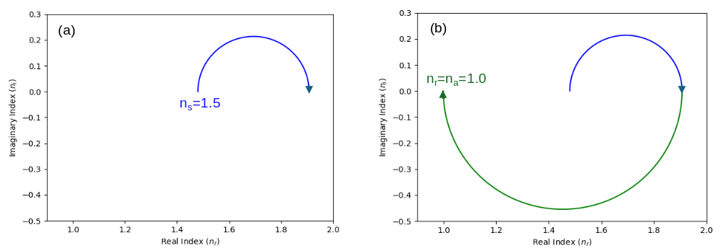
Fig. 1. Contour graphs show the reflectivity (real index) and phase difference (imaginary index) of an example design with ns=1.5, nf1=1.7 and nf2=1.4. (a) nf1 deposited on top of ns. (b) nf2 deposited on top of nf1. Both films are quarter-wave thick.

The limitation of using QWOT films for AR design is the selection of materials with correct refractive index. An easier method is to control the thickness of each film. This can be archive by drawing the full contours circle for both films. The contour of the first film is plotted from the substrate index like usual. But the second film contour is plotted from the air. For example, a common substrate is SiO₂ with n_{s}=1.48, Al₂O₃ a refractive index of n_{f1}=1.77 similar, and MgF₂ is n_{f2}=1.38, as shown in Figure 2.

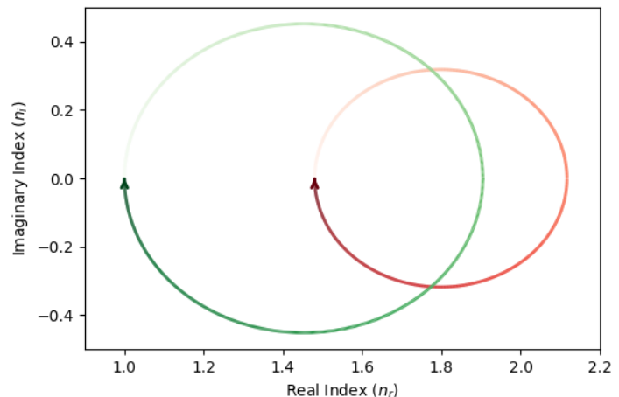
Fig. 2. Contour graph shows the reflectivity of an example design with n_{s}=1.48, n_{f1}=1.77 (red) and n_{f2}=1.38 (green).

The interception points of the two lines can be solved for thicknesses with non-linear solver, such as fsolve. The number of answers in this example is two, as show in Fig 3.

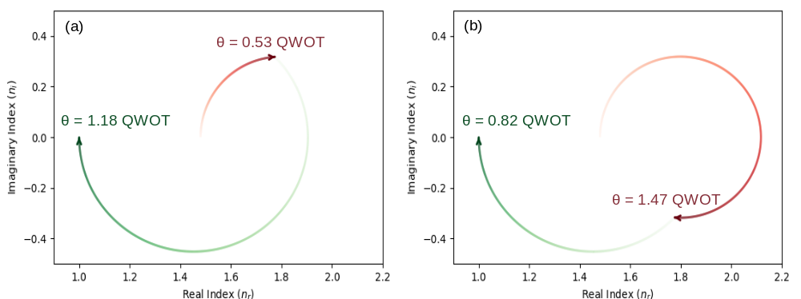
Fig. 3. Contour graphs show the two possible answers for perfect antireflection.

2.3 Asymmetrical resonance cavity design.
A resonant cavity is a useful design for enhancing the optical properties of central cavity layer, which in this study will be PCM. A distributed Bragg reflector cavity consists of two reflecting layers placed on either side of the central layer. The two reflectors cause light to cycle through the central layer multiple times, which effectively reduced the required thickness of PCM. The mirror on each side is created from a unit cell (U) composed of materials with high (H) and (L) refractive index with quarter-wave optical thickness. The larger the difference, the better the enhancement. In this work, unit cell will be denoted as [H/2 L H/2], where 1/2 indicates a film with half the QWOT. As an example, if we use 1 unit cell on each side, and also have H as the central cavity layer, the structure can be written as
$\left[\frac{H}{2}L\frac{H}{2}\right]H\left[\frac{H}{2}L\frac{H}{2}\right]$. (7.1)
By combining the central H with the two adjacent H/2, we get
$\frac{H}{2} L HH L \frac{H}{2}$. (7.2)
The combination of two QWOT films with the same index creates half-wave optical thickness (HWOT) layer, which is equivalent to an absentee layer (loss less). The two adjacent Hs and the two Ls can be combined, with the final structure reduced to an equivalent of a single quarter-wave thick H layer.
$\frac{H}{2} \frac{H}{2}$, (7.3)
$H$. (7.4)
For a multi-unit-cell design, the notation of equation 7.1 can be rewritten as [U]^{N} C [U]^{M}, where N is the number of unit cell on the substrate side, C is the central cavity layer (H in this example), and M is the number of unit cell on the incident side.
But when the central cavity layer is made from PCM or metal which their refractive index has a value in the imaginary term (extinction coefficients; k). This absorption leads to a loss of resonance. Figure 4 demonstrates the effect with symmetrical U³ on each side, n_{H}=2.23, n_{L}=1.46. For Fig.4(a) a resonant can be create with central layer consisted of only the real part in the refractive index, n_{C}=3.15. But Fig.4(b) with n_{C}=3.15-0.35j, an AR design is impossible.
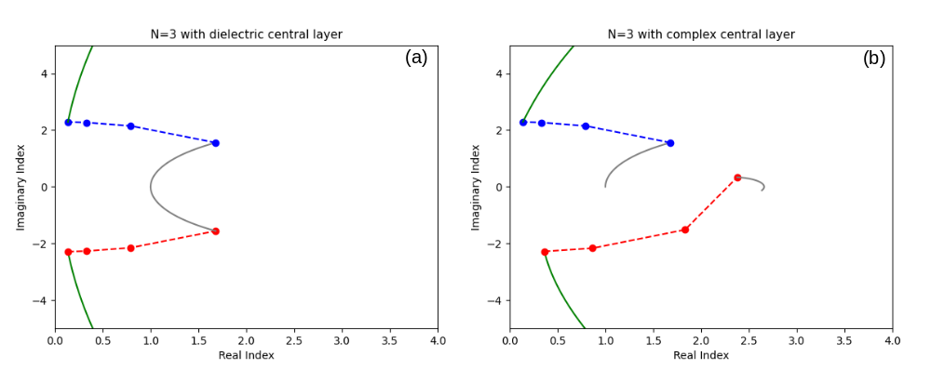
Fig. 4. Contours of 3 unit-cells symmetrical cavity. Blue is the number of unit cell on the substrate side N, red is the number on the incident side M, and green is the central layer C. (a) The central layer is made from n_{C}=3.15. (b) The central layer has extinction coefficient, n_{C}=3.15-0.35j, which moves the final n_{r} away from n_{a}. Reprinted from [35].

To partially restore the AR condition, the number of unit cell of the incident side is reduced to 1, as show in Fig. 5. This redesign adjusts the final n_{r} closer to n_{a}.
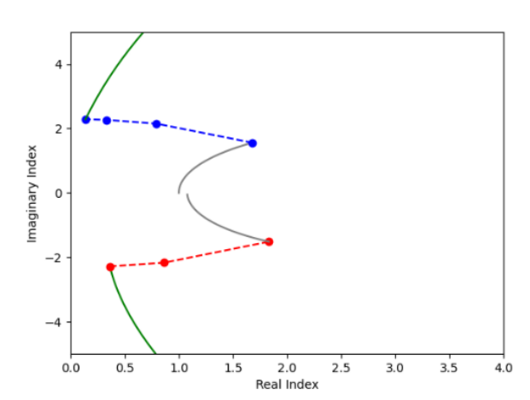
Fig. 5. Contours of asymmetrical cavity. With reduced number of unit cell on the incident side to M=2 (red) the final n_{r} is now closer to n_{a}. Reprinted from [35].

A resonant can be fully restore by adding a compensator layer with zero extinction coefficient in the central layer, as shown in Fig. 6.
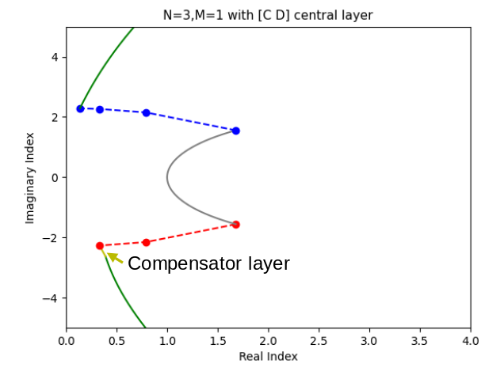
Fig. 6. Contours of a restored resonant cavity. The compensator layer (yellow) can be made from dielectric with appropriate thickness. Also reprinted from [35].

3. Method
In this work, we investigate various Sb₂Se₃ designs using computer simulation of transfer matrix method (TMM) to calculate the transmittance, absorptance, and reflectance of the entire devices. We use Silicon nitride (Si₃N₄) as H-index film [36] and Silicon dioxide (SiO₂) as L-index film [37], both dataset can be found on refractiveindex.info website [38]. The Antimony triselenide (Sb₂Se₃) data used is taken from literature [16]. We assume air to have a constant index across all wavelengths, and assume the substate to be air which can be done in reality by simply adding a compensating layer on substrate-air interface. We decide to investigate Sb₂Se₃ based optical limiter with resonant cavity designed for two different wavelengths, 1064 and 532 nm.
At 532 nm, Sb₂Se₃ has high extinction coefficients value in both phase, and this cause a resonant condition for a perfect antireflection design to be unarchivable with conventional QWOT film or resonant cavity designs. Perfect antireflection condition can be restored by asymmetrical cavity design described in section 2.

4. Results (and Discussion ?)

4.1 1,064-nm resonant cavity
At 1064 nm, the refractive index of amorphous and crystalline Sb₂Se₃ is 3.3697+0.0000j and 4.3081+0.0097j, respectively [16]. The extinction coefficient (k) of Sb₂Se₃ is zero for amorphous and at near-zero value for crystalline phase. This make Sb₂Se₃ devices highly efficient, with little to no loss from light absorption. But this behavior prevents the design of some optical device, such as a self-activating optical limiter. A secondary laser with wavelength in the visible light, or a heat plate is required as a switching mechanism. One method to increase transmission and absorption is to design a device with antireflection (AR) property. The simplest AR design is from a single layer of Sb₂Se₃ film that have quarter-wave optical thickness (QWOT). And to further increase the absorptivity, we could use a Fabry–Pérot cavity. A cavity with perfect antireflection design is ideal for increasing the absorptivity and maintaining high transmissivity. But a cavity can only be designed for one perfect resonant in one phase, either amorphous or crystalline Sb₂Se₃ phases. If we want the device to have self-activating property at the 1064 nm, then a resonant in amorphous phase is required to lower the activating threshold. But if we already use external means, such as visible-light laser, then a resonant in crystalline phase can be used to lower the required light intensity for re-amorphization process.
Figure 7 shows the transmission and reflection properties of an optical limiter in amorphous and crystalline phase and the phase in resonant is amorphous Sb₂Se₃. Figure 7a is from a single layer Sb₂Se₃ that is quarter-wave optical thick. And Fig. 7b is a resonant cavity with Sb₂Se₃ in the center and symmetrical, single unit cell (U) of [H/2 L H/2] on each side. This design can be written as U¹ Sb₂Se₃ U¹. Both design have perfect antireflection, and perfect transmission at 1064 nm wavelength. The full-width at half maximum (FWHM) of the peak transmission from single QWOT film (Fig. 7a) is wider than the one from the cavity design (Fig. 7b). And the red-shift of transmission peak from phase transition is wider for QWOT design. These cause the transmission contrast between the on mode (amorphous) and off mode (crystalline) of a QWOT design to be higher than from a cavity design.
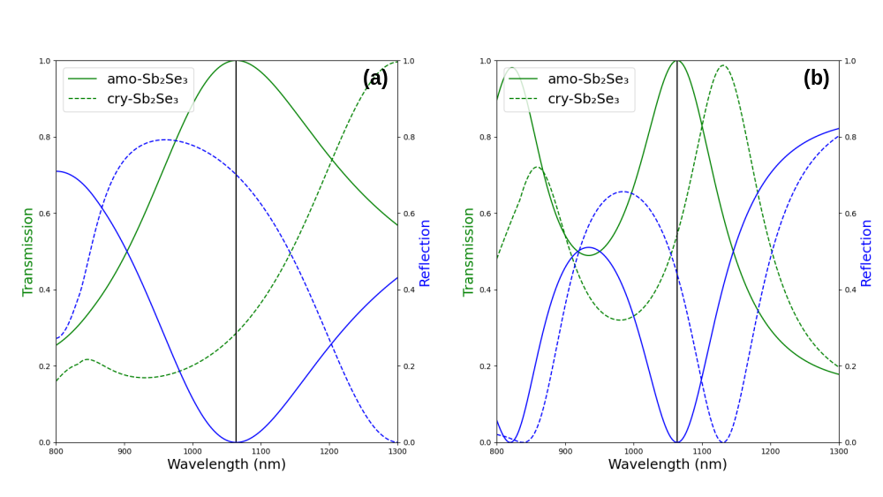
Fig. 7. Transmission and reflection spectra from 800 to 1300 nm of (a) Sb₂Se₃ with quarter-wave optical thickness and (b) resonant cavity with Sb₂Se₃ as the central layer. The transmission is in green and reflection is in blue. Line represents the optical properties while Sb₂Se₃ is in amorphous phase, and dashed line represents properties while Sb₂Se₃ is in crystalline phase. Black vertical line is the operating wavelength (1064 nm).

Table 1 shows the transmission and absorption properties of antireflection QWOT and cavity designs. The required Sb₂Se₃ required for perfect antireflection in a cavity design is less than a single-layer QWOT design. With increasing number of unit cell results in requiring less Sb₂Se₃. The transmission contrast of a cavity design become higher than QWOT design when using 2 or more unit cells on each side of the cavity. High transmission contrast is ideal for an efficient optical limiter, but the overall device thickness increased with cavity design. In fact, a design with just two unit cells on each side of the cavity is enough to make the device over a micrometer thick, almost 10 times as thick compared to a QWOT design. Lastly, the absorptivity did not increase with increasing number of unit cell. This is because the extinction coefficient of amorphous Sb₂Se₃ is zero at 1064 nm. An unreasonable amount of unit cells would be required to make any meaningful enhancements in absorption.

Table 1 The Optical properties at 1064 nm of each design. The absorption is from amorphous phase (on mode).

Design | Sb₂Se₃ used (nm) | Device thickness (nm) | Transmission |  |  | Absorption (%)
Design | Sb₂Se₃ used (nm) | Device thickness (nm) | Amorphous (%) | Crystalline (%) | Contrast (%) | Absorption (%)
QWOT (Fig. 7a) | 157.9 | 157.9 | 100.0 | 28.6 | 71.4 | 0.0
U¹ SbSe U¹ (Fig. 7b) | 107.3 | 896.6 | 100.0 | 54.4 | 45.6 | 0.0
U² SbSe U² | 105.0 | 1496.4 | 100.0 | 26.6 | 73.4 | 0.0
U³ SbSe U³ | 104.4 | 2124.8 | 100.0 | 9.6 | 90.4 | 0.0

Another way around the problem of zero k-value of amorphous Sb₂Se₃ at 1064 nm is to use crystalline Sb₂Se₃ as on mode instead since its complex refractive index is 4.3081+0.0097j at 1064 nm. A cavity could help increase the absorption enhancement so that the re-amorphization process could be done by the 1064-nm operating wavelength. Table 2 is the optical properties of various antireflection design with resonant condition in the crystalline Sb₂Se₃ phase. The absorptivity did not increase with the increasing numbers of unit cell in a significant manner. The number of unit cells required for significant absorption would be unrealistic, just like in the previous amorphous-phase design (table 1). This is because the cavity design required less Sb₂Se₃ than a QWOT design for a perfect antireflection condition. Fewer Sb₂Se₃ means reduced absorption, even after a cavity enhancement. And the k-value at this wavelength is not high enough.

Table 2 The Optical properties at 1064 nm of each device. The absorption is from crystalline phase (on mode).

Design | Sb₂Se₃ used (nm) | Device thickness (nm) | Transmission |  |  | Absorption (%)
Design | Sb₂Se₃ used (nm) | Device thickness (nm) | Crystalline (%) | Amorphous (%) | Contrast (%) | Absorption (%)
QWOT | 123.5 | 123.5 | 96.8 | 51.5 | 45.3 | 3.0
U¹ SbSe U¹ | 92.2 | 854.5 | 98.0 | 73.5 | 24.5 | 2.0
U² SbSe U² | 90.2 | 1481.6 | 96.8 | 44.4 | 52.4 | 3.2
U³ SbSe U³ | 89.6 | 2110.1 | 94.4 | 18.8 | 75.6 | 5.5

Instead of self-switching by the operating wavelength itself, a secondary light source could be used to induce phase transition via optical heating. Lawson, et al. [14] use a 480-nm diode laser as optical pump to change Sb₂Se₃ phases because of the high extinction coefficient at this wavelength for both phases. But pump laser at this wavelength can cause partial amorphization if the Sb₂Se₃ thickness exceed 200 nm. They solve this by optimizing the pulse parameters (i.e. pulse duration, power). Being able to use laser with longer wavelengths, in the visible light for example, should make the optimization of the laser pump parameter easier. Even though we want to use the same pump laser for both phase transitions, ideally the absorption in crystalline phase should be higher. This is because the transition temperature for re-amorphization is a lot higher than the crystallization temperature. Figure 8 is the transmission and absorption spectra of 1064-nm optical limiter designs previously described. Figure 8a is a single layer QWOT design and Fig. 8b is a cavity with U² on each side of the cavity. A cavity design (Fig. 8b) has a higher absorption peak, at around 530 nm, in both phase than QWOT design (Fig. 8a). But QWOT has a wider peak absorption range, which could aid with the selection of pump laser.
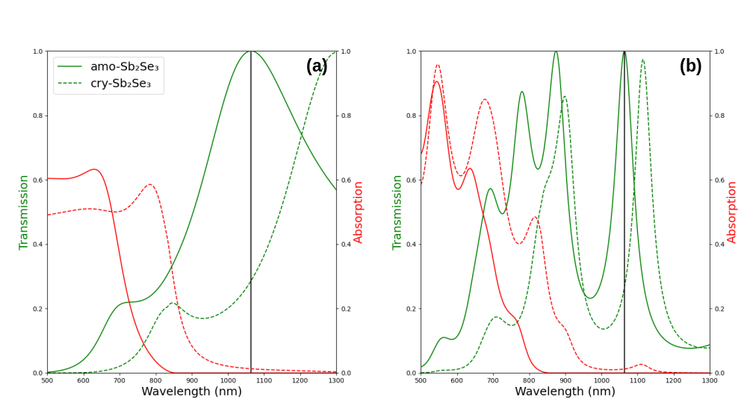
Fig. 8. Transmission and absorption spectra from 500 to 1300 nm of: (a) The previous single layer QWOT design (Fig. 7a). And (b) resonant structure with U² on both side of the cavity. Both (a) and (b) are design for antireflection condition at 1064 nm in amorphous phase.

Instead of using an existing 1064-nm AR designs from table 1 or table 2 and selecting the optical pump with appropriate wavelength in the visible light regime, we work backward and select the laser pump wavelength first. For example, if we want to use 700-nm laser pump for 1064-nm optical limiter, we could design a perfect AR condition at 700 nm range and tune for transmission value suitable for a 1064-nm optical limiter. However, this does have its limitation because the only tunable parameters are the number of unit cell on each side of the cavity and the central cavity layer layout. The number of unit cell is an integer, and there’re only finite central cavity layout combinations.

While the crystallization temperature of Sb₂Se₃ is relatively low compared to other non-volatile PCM, it has zero absorptivity at infrared wavelengths. The number of unit cells required for any meaningful absorption enhancement would be unrealistically large. So, we decided to investigate the resonant enhancement when Sb₂Se₃ is in crystalline phase. Figure 7a is the transmission and reflection spectra of an antireflection design from a single quarter-wave-thick Sb₂Se₃ film (157.9 nm).

When compared to a Fabry–Pérot resonant cavity design with a single unit cell on both sides of the cavity, as shown in Figure 7b,.

With resonant cavity, we can design the cavity to exhibits absorption enhancement in the amorphous phase, this can lower the power requirement from the laser such that the intensity of the intended operating wavelength is enough for phase transition. The simplest design is an

4.2 ~700-nm resonant cavity

4.2 532-nm resonant cavity
As for 532-nm optical limiter, the extinction coefficient of Sb₂Se₃ at this wavelength is significantly higher than at 1064 nm wavelength. This cause a problem with resonant for an antireflection design, be it a simple single layer QWOT film or a more complex Fabry–Pérot resonant cavity. The loss of resonant can be restored by a method described in section 2. [Might be a duplication of Method, pick one] [Too similar to [32].

Endurance

5. Discussion:

Asymmetrical designs are the only way to restore resonance for a device comprised of a high extinction coefficient value, as shown in [result 532]. The transmission differences between the two modes are higher than the normal HWOT design. The absorptions (loss) in the operating mode (amorphous) for asymmetrical design are lower, which are caused by using much thinner central layer film. While the absorptions in the blocking mode (crystalline) are also higher, which would aid with the re-amorphization process, the process that required much higher temperature than crystallization.

Even though the expansion and contraction of Sb₂Se₃ was mentioned in the introduction [14, 33]. We have not accounted for this phenomenon during the simulations. This is because each of the references only mention in one thickness and phase transition condition. And we lack fabrication capability to measure this phenomenon. The expansion and contraction

But the [result 1064] also demonstrate a case where asymmetrical design is unnecessary, such as low absorption in the central layer. In this case, the symmetrical has a comparable to the best asymmetrical designs, with much lower overall device thickness. The gain from cavity design is negligible unless we want the design to want a high absorption design, which could also be done easier by another appropriate materials.

Antimony triselenide have low extinction coefficient (k) in the IR spectrum. But this is not the case for the visible light spectrum. The question is why we would use Sb2Se3 over other common PCMs such as GST or GSST. GST has a comparable crystallization temperature, but the Δn contrast is higher than that of Sb2Se3 this came at a cost of higher absorption in the visible light spectrum for both phases. As for GSST, it has a lower Δn, comparable to Sb2Se3. Its extinction coefficient is lower than both GST and Sb2Se3, which generally makes the device absorptivity smaller in the vis-spectrum, which mean more efficient device.
An optical limiter is designed with an external method to change the phase (e.g., joule heating, light-intensity induced temperature with a wavelength other than the operating mode).
But because the refractive index of Sb₂Se₃ is still inconsistent. We decided not to compare our device to other designs, the purpose of this study is to investigate two extreme use cases of resonant cavity.

This mathematical-based design method will result in perfect anti-reflection in one operating mode. In this work, we picked amorphous phase as the default operating mode, since crystallization temperature is much lower than re-amorphization temperature. But the same design approach is also applicable to the crystalline phase as the default mode.

One limitation of the asymmetrical design is the lack of tunability, since there can only be a limited answer to the contour equation. Another approach could be to use a genetic algorithm to optimize the design further [33].

The authours’ previous work is on the simulation of VO2 optical limiter for 1,320 and 1,550 nm wavelengths [35]. We found that the article for the selected reference designs didn’t provide a refractive index dataset for every material. So, when recreated with an external dataset, the optical properties of the devices can’t be recreated. The difference might be due to a different fabrication process. Which makes a direct comparison impossible. In this work, we also found the lack of datasets provided in many of the papers on Sb2Se3 devices, and the data provided are in conflict with each other. The suggested future work is on the real-world fabrications of the designs, which the authors currently lack the means to do.

Non-linear effect.
Aside from large Δn in the two phases, Sb2Se3 also exhibits strong non-linearity dependent on light intensity (Kerr’s effect). And since this could affect its resonance when used with a high-power laser, even before the energy from the laser is large enough to heat the device to its transition temperature, we also computationally demonstrate this scenario using non-linearity data from [citation needed] and compared it to [Go-Sb2Se3].

Other properties
Sb₂Se₃ contraction and expansion from crystallization and re-amorphization process [33].
Vary the incident angle from 0-90°. Because the nature of resonant cavity is to amplify the central layer, and is design for a single wavelength. Any incident angle will affect the transmission, absorption, and reflection much more than a simple layer film.

6. Conclusion:
Fine tuning of absorption enhancement using a Fabry–Pérot resonant cavity when the extinction coefficient (k) is small, i.e. at 1064 nm, is not as straightforward as when k is large. For a situation where the k-value is very high, an asymmetrical resonant cavity design is the only way to restore resonance condition. A cavity design will lower the thickness of Sb₂Se₃ required for a perfect antireflection condition when compared to a single-layer quarter-wave optical thickness (QWOT) design, but the overall device will thickness will be larger.

Declaration of generative AI and AI-assisted technologies in the manuscript preparation process.
Statement (example): During the preparation of this work the author(s) used [NAME OF TOOL / SERVICE] in order to [REASON]. After using this tool/service, the author(s) reviewed and edited the content as needed and take(s) full responsibility for the content of the published article.
During the preparation of this work the authors used Consensus to do a literature search for photonic application of Sb₂Se₃, and Gemini for grammar and logic check. After using these tools, the authors have reviewed and edited the content as needed and take full responsibility for the content of the published article. (10/01/2026)

References:

[1] M. Wuttig, H. Bhaskaran, and T. Taubner, "Phase-change materials for non-volatile photonic applications," Nature Photonics, vol. 11, no. 8, pp. 465–476, 2017/08/01 2017, doi: 10.1038/nphoton.2017.126.
[2] K. Matuszek, M. Kar, J. M. Pringle, and D. R. MacFarlane, "Phase Change Materials for Renewable Energy Storage at Intermediate Temperatures," Chemical Reviews, vol. 123, no. 1, pp. 491–514, 2023/01/11 2023, doi: 10.1021/acs.chemrev.2c00407.
[3] R. Matos and N. Pala, "A Review of Phase-Change Materials and Their Potential for Reconfigurable Intelligent Surfaces," Micromachines, vol. 14, no. 6, p. 1259, 2023. [Online]. Available: https://www.mdpi.com/2072-666X/14/6/1259.
[4] A. Sarangan, J. Duran, V. Vasilyev, N. Limberopoulos, I. Vitebskiy, and I. Anisimov, "Broadband Reflective Optical Limiter Using GST Phase Change Material," IEEE Photonics Journal, vol. 10, no. 2, pp. 1–9, 2018, doi: 10.1109/JPHOT.2018.2796448.
[5] R. Heenkenda, K. Hirakawa, and A. Sarangan, "Tunable optical filter using phase change materials for smart IR night vision applications," Opt. Express, vol. 29, no. 21, pp. 33795–33803, 2021/10/11 2021, doi: 10.1364/OE.440299.
[6] D. d. Ceglia, M. Grande, A. Vincenti, C. Baratto, and C. d. Angelis, "Tunable Filters for Visible Light Based on Resonant VO2 Planar Thin Films," in 2020 22nd International Conference on Transparent Optical Networks (ICTON), 19–23 July 2020 2020, pp. 1–4, doi: 10.1109/ICTON51198.2020.9203244.
[7] H. Kocer et al., "Intensity tunable infrared broadband absorbers based on VO2 phase transition using planar layered thin films," Scientific Reports, vol. 5, no. 1, p. 13384, 2015/08/21 2015, doi: 10.1038/srep13384.
[8] X. Tian and Z.-Y. Li, "An Optically-Triggered Switchable Mid-Infrared Perfect Absorber Based on Phase-Change Material of Vanadium Dioxide," Plasmonics, vol. 13, no. 4, pp. 1393–1402, 2018/08/01 2018, doi: 10.1007/s11468-017-0643-9.
[9] E. Strelcov, Y. Lilach, and A. Kolmakov, "Gas Sensor Based on Metal−Insulator Transition in VO2 Nanowire Thermistor," Nano Letters, vol. 9, no. 6, pp. 2322–2326, 2009/06/10 2009, doi: 10.1021/nl900676n.
[10] R. Kononchuk et al., "A free-space mm-wave photonic limiter," in 2022 Conference on Lasers and Electro-Optics (CLEO), 15–20 May 2022 2022, pp. 1–2.
[11] M. G. Wood et al., "Optically-Triggered Optical Limiters for Short-Wavelength Infrared Sensor Protection," in 2021 Conference on Lasers and Electro-Optics (CLEO), 9–14 May 2021 2021, pp. 1–2.
[12] C. Wan et al., "Ultrathin Broadband Reflective Optical Limiter," Laser & Photonics Reviews, vol. 15, no. 6, p. 2100001, 2021, doi: https://doi.org/10.1002/lpor.202100001.
[13] P. Xu, J. Zheng, J. K. Doylend, and A. Majumdar, "Low-Loss and Broadband Nonvolatile Phase-Change Directional Coupler Switches," ACS Photonics, vol. 6, no. 2, pp. 553–557, 2019/02/20 2019, doi: 10.1021/acsphotonics.8b01628.
[14] D. Lawson, S. Blundell, M. Ebert, O. L. Muskens, and I. Zeimpekis, "Optical switching beyond a million cycles of low-loss phase change material Sb2Se3," Opt. Mater. Express, vol. 14, no. 1, pp. 22–38, 2024/01/01 2024, doi: 10.1364/OME.509434.
[15] C. Wan et al., "Limiting Optical Diodes Enabled by the Phase Transition of Vanadium Dioxide," ACS Photonics, vol. 5, no. 7, pp. 2688–2692, 2018/07/18 2018, doi: 10.1021/acsphotonics.8b00313.
[16] M. Delaney, I. Zeimpekis, D. Lawson, D. W. Hewak, and O. L. Muskens, "A New Family of Ultralow Loss Reversible Phase-Change Materials for Photonic Integrated Circuits: Sb2S3 and Sb2Se3," Advanced Functional Materials, vol. 30, no. 36, p. 2002447, 2020, doi: https://doi.org/10.1002/adfm.202002447.
[17] Y. Zhang et al., "Broadband transparent optical phase change materials for high-performance nonvolatile photonics," Nature Communications, vol. 10, no. 1, p. 4279, 2019/09/30 2019, doi: 10.1038/s41467-019-12196-4.
[18] Z. Gong et al., "Phase change materials in photonic devices," Journal of Applied Physics, vol. 129, no. 3, 2021, doi: 10.1063/5.0027868.
[19] M. E. A. Warwick and R. Binions, "Advances in thermochromic vanadium dioxide films," Journal of Materials Chemistry A, 10.1039/C3TA14124A vol. 2, no. 10, pp. 3275–3292, 2014, doi: 10.1039/C3TA14124A.
[20] P. Guo, Z. Biegler, T. Back, and A. Sarangan, "Vanadium dioxide phase change thin films produced by thermal oxidation of metallic vanadium," Thin Solid Films, vol. 707, p. 138117, 2020/08/01/ 2020, doi: https://doi.org/10.1016/j.tsf.2020.138117.
[21] Y. Cui et al., "Thermochromic VO2 for Energy-Efficient Smart Windows," Joule, vol. 2, no. 9, pp. 1707–1746, 2018/09/19/ 2018, doi: https://doi.org/10.1016/j.joule.2018.06.018.
[22] N. Murillo-Quirós, V. Vega-Garita, A. Carmona-Calvo, E. A. Rojas-González, R. Starbird-Perez, and E. Avendaño-Soto, "Toward Thermochromic VO2 Nanoparticles Polymer Films Based Smart Windows Designed for Tropical Climates," Polymers, vol. 14, no. 19, p. 4250, 2022. [Online]. Available: https://www.mdpi.com/2073-4360/14/19/4250.
[23] C. Chen et al., "Optical properties of amorphous and polycrystalline Sb2Se3 thin films prepared by thermal evaporation," Applied Physics Letters, vol. 107, p. 043905, 2015.
[24] X. Chen, J. Lin, and K. Wang, "A Review of Integrated Photonic Devices Using Sb2Se3," Advanced Physics Research, vol. 4, no. 1, p. 2400080, 2025, doi: https://doi.org/10.1002/apxr.202400080.
[25] K. Aryana et al., "Optical and thermal properties of Ge2Sb2Te5, Sb2Se3, and Sb2S3 for reconfigurable photonic devices [Invited]," Opt. Mater. Express, vol. 13, no. 11, pp. 3277–3286, 2023/11/01 2023, doi: 10.1364/OME.503178.
[26] J. Faneca et al., "Towards low loss non-volatile phase change materials in mid index waveguides," Neuromorphic Computing and Engineering, vol. 1, no. 1, p. 014004, 2021/08/23 2021, doi: 10.1088/2634-4386/ac156e.
[27] S. Blundell et al., "Ultracompact Programmable Silicon Photonics Using Layers of Low-Loss Phase-Change Material Sb2Se3 of Increasing Thickness," ACS Photonics, vol. 12, no. 3, pp. 1382–1391, 2025/03/19 2025, doi: 10.1021/acsphotonics.4c01789.
[28] W. Jia, R. Menon, and B. Sensale-Rodriguez, "Unique prospects of phase change material Sb2Se3 for ultra-compact reconfigurable nanophotonic devices," Opt. Mater. Express, vol. 11, no. 9, pp. 3007–3014, 2021/09/01 2021, doi: 10.1364/OME.435979.
[29] M. Gandolfi et al., "Optical Limiting Thin Multilayer Films Based On Phase Transition In VO2," in 2022 Sixteenth International Congress on Artificial Materials for Novel Wave Phenomena (Metamaterials), 12–17 Sept. 2022 2022, pp. 148–150, doi: 10.1109/Metamaterials54993.2022.9920767. [Online]. Available: https://ieeexplore.ieee.org/stampPDF/getPDF.jsp?tp=&arnumber=9920767&ref=
[30] C. Baratto et al., "Optical Limiting Sensor Based on Multilayer Optimization of Ag/VO2 Phase Change Material," IEEE Sensors Letters, vol. 7, no. 9, pp. 1–3, 2023, doi: 10.1109/LSENS.2023.3300801.
[31] A. Tognazzi et al., "Opto-thermal dynamics of thin-film optical limiters based on the VO2 phase transition," Opt. Mater. Express, vol. 13, no. 1, pp. 41–52, 2023/01/01 2023, doi: 10.1364/OME.472347.
[32] A. Sarangan, "Design of resonant cavity thin film structures with complex active layers," J. Opt. Soc. Am. B, vol. 37, no. 11, pp. 3461–3468, 2020/11/01 2020, doi: 10.1364/JOSAB.404894.
[33] Y.-S. Huang et al., "Tunable structural transmissive color in fano-resonant optical coatings employing phase-change materials," Materials Today Advances, vol. 18, p. 100364, 2023/06/01/ 2023, doi: https://doi.org/10.1016/j.mtadv.2023.100364.
[34] A. Sarangan, Optical Thin Film Design, 1st Edition ed. Boca Raton: CRC Press, 2020.
[35] C. Padungatthakij, S. Wicharn, and P. Buranasiri, Asymmetrical resonant cavity thin film devices designed for vanadium dioxide applications (International Workshop on Thin Films for Electronics, Electro-Optics, Energy, and Sensors). SPIE, 2025.
[36] L. Y. Beliaev, E. Shkondin, A. V. Lavrinenko, and O. Takayama, "Optical, structural and composition properties of silicon nitride films deposited by reactive radio-frequency sputtering, low pressure and plasma-enhanced chemical vapor deposition," Thin Solid Films, vol. 763, p. 139568, 2022/12/01/ 2022, doi: https://doi.org/10.1016/j.tsf.2022.139568.
[37] L. Gao, F. Lemarchand, and M. Lequime, "Exploitation of multiple incidences spectrometric measurements for thin film reverse engineering," Opt. Express, vol. 20, no. 14, pp. 15734–15751, 2012/07/02 2012, doi: 10.1364/OE.20.015734.
[38] M. N. Polyanskiy, "Refractiveindex.info database of optical constants," Scientific Data, vol. 11, no. 1, p. 94, 2024/01/18 2024, doi: 10.1038/s41597-023-02898-2.

